Application Deployment on AWS
step1-
Fork the web-app file project GitHub repository and create an ECR to store the Docker images
Step2-
Modify the build configuration file in the GitHub repository to include the ECR image URI
Step3-
Create an ECS cluster using the Fargate launch type and configure an ECS service to run tasks on the cluster
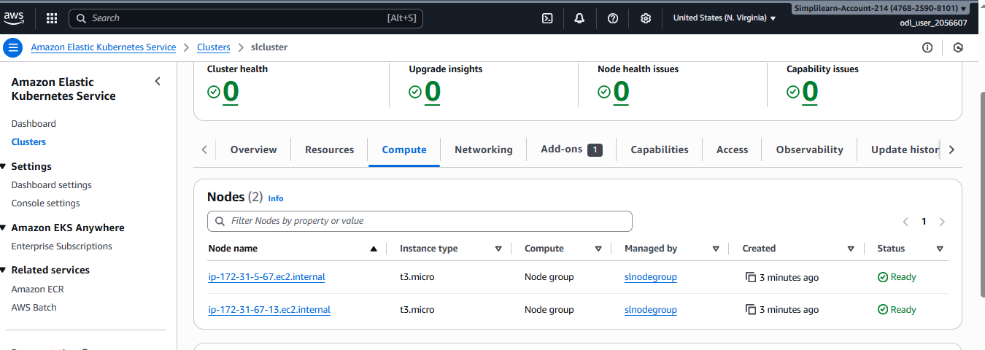
Step4-
Deploy the application

